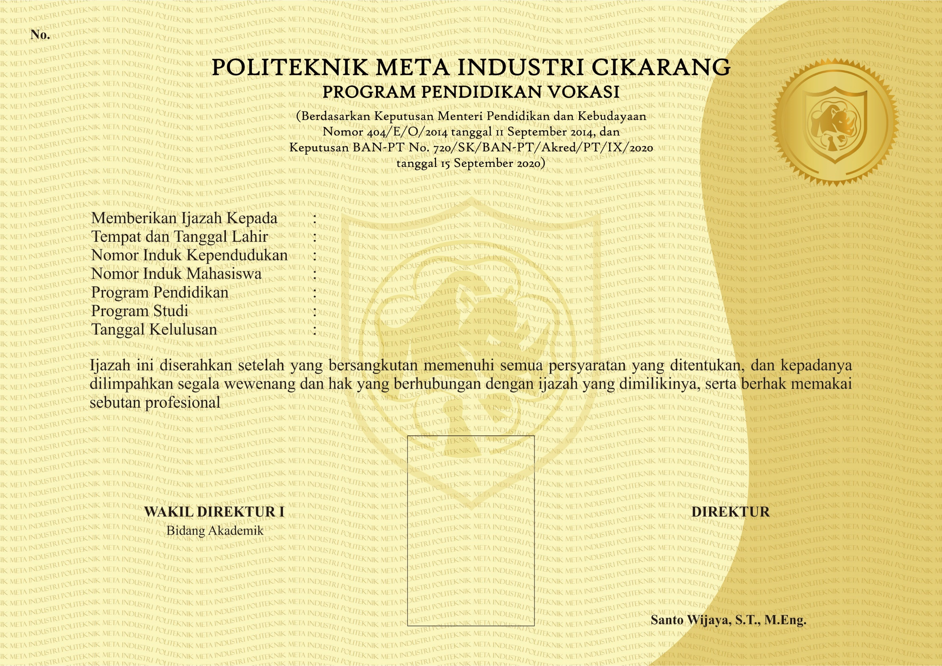­

**484012021000264**

**Nurina Audia Widyanto**

Kuningan, 4 November 1997

3275114411970000

1824809

Farmasi

Diploma III (D-III)

**Ahli Madya Farmasi (A.Md.Farm.)**

**Cikarang, 11 Desember 2021**

**Fransisca Debora, S.Si., M.T.**

31 Agustus 2021